1. Write a program to illustrate the structure of c++?

#include<iostream>

#include<conio.h>

using namespace std;

int main()

{

cout << "hai Welcome to c++";

return 0;

}

OUTPUT:-

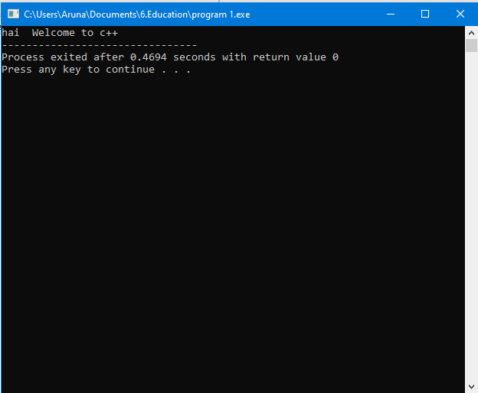

2. Write a program to declare and initialize variables in

c++?

#include<iostream>

#include<conio.h>

using namespace std;

int main()

{

int a;

cout<<"Enter an integer value :\n";

cin>>a;

cout<<"The variable declared as int "<<a;

}

OUTPUT

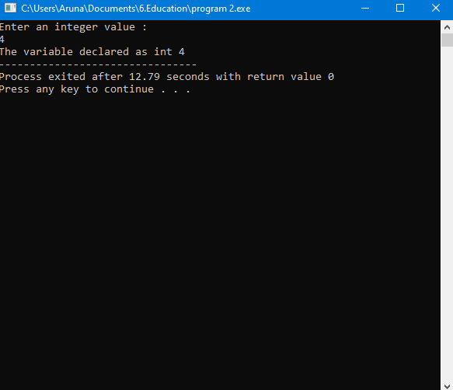

3.Write a program using constant values?

#include<iostream>

#include<conio.h>

using namespace std;

#define val 10;

#define float 23.4

int main()

{

cout<<"Name : ARUNA KUMARI(S170354)\n";

cout<<"Integer constant is : \n"<<val<<endl;

cout<<"Float value is :\n"<<float<<endl;

return 0;

}

OUTPUT:-

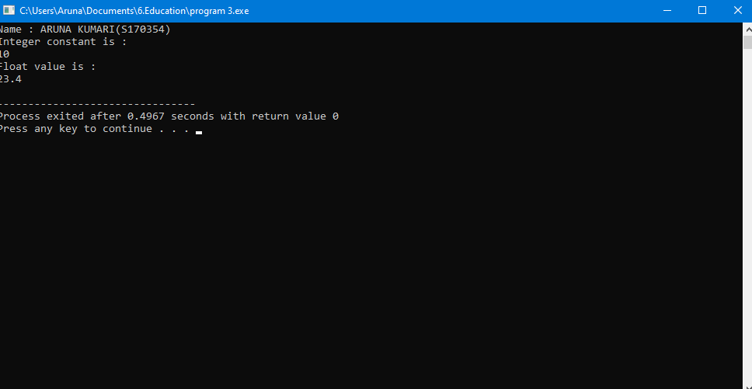

4.Write a c++ program to perform various operations?

#include<iostream>

#include<conio.h>

using namespace std;

int main()

{

int a,b,ch;

while(1)

{

cout<<"\t**ARITHMATIC OPERATIONS**\n";

cout<<"\n1.Addition\n2.Substraction\n3.Multiplication\n4.Division\n5.Modulus\n6.Quit\n";

cout<<"Enter the a and b values :\n";

cin>>a>>b;

cout<<"Enter your choice :\n";

cin>>ch;

switch(ch)

{

case 1 :

{

cout<<"Addition of two numbers : \n"<<a+b;

break;

}

case 2 :

{

cout<<"Substraction of teo numbers :\n"<<a-b;

break;

}

case 3 :

{

cout<<"Multiplication of two numbers : \n"<<a*b;

break;

}

case 4 :

{

cout<<"Division of two numbers : \n"<<a/b;

break;

}

case 5 :

{

cout<<"Modulus of two numbers : \n"<<a%b;

break;

}

case 6 :

{

exit(0);

break;

}

default :

cout<<"Enter the valid option\n";

}

}

}

OUTPUT:-

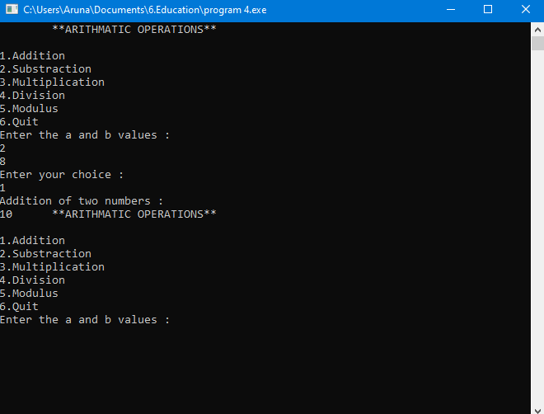

5. Write a program using scope access operator?

#include<iostream>

using namespace std;

int a = 20;

int main()

{

int a = 10;

cout << "Value of local a: " << a << endl;

cout << "Value of global a: " << ::a << endl;

return 0;

}

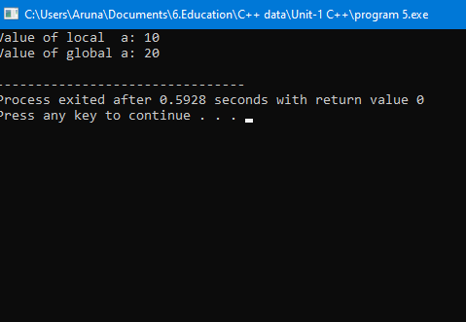

6.Write a program to check whether the given number is

even or odd?

#include<iostream>

#include<conio.h>

using namespace std;

int main()

{

int num,i;

cout << "Enter a number : \n";

cin >> num;

if(num%2==0)

{

cout <<"The given number is a even number \n";

}

else

{

cout << "The given number is not a even number \n";

}

}

Output :-

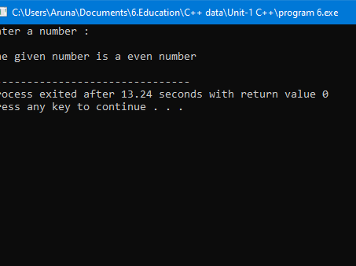

7. Write a c++ program to swap two given numbers with

and without using extra variable?

#include<iostream>

#include<conio.h>

using namespace std;

int main()

{

int num1,num2;

int var1,var2,temp;

cout <<"\nEnter the value of num1 : \n ";

cin >>num1;

cout << "\nEnmter the value of num2 : \n";

cin >>num2;

num1=num1+num2;

num2=num1-num2;

num1=num1-num2;

cout << "The values of num1 and num2 after swapping are : \n" <<num1 <<"\n" <<num2;

cout <<"Enter the value of var1 : \n";

cin >>var1;

cout <<"Enter the value of var2 : \n";

cin>>var2;

temp=var1;

var1=var2;

var2=temp;

cout <<"The values of var1 and vafr2 are : \n" <<var1 <<"\n"<<var2;

return 0;

}

Output :-

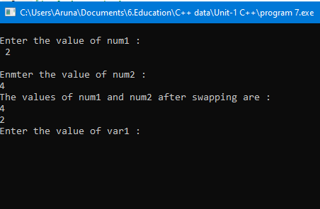

1. Write a program to check whether the given number is perfect square or not?

#include<iostream>

#include<conio.h>

using namespace std;

int main()

{

int num,i;

cout <<"Enter a number : \n";

cin >>num;

for(i=1;i<=num;i++)

{

if(num==i*i)

{

cout <<"The given number is a perfect square number \n";

}

else

{

cout <<"The given number is not a perfect square number \n";

}

}

return 0;

}

OUTPUT:-

1. Write a program to check whether the given number is palindrome or not?

#include<iostream>

#include<conio.h>

using namespace std;

int main()

{

int num,rev,rem,n;

cout <<"Enter a number \n";

cin >>num;

n=num;

while( n!=0 )

{

rem=n%10;

rev=rev*10+rem;

n /= 10;

}

if(num==rev)

{

cout <<"\nThe given number is a palindrome \n";

}

else

{

cout <<"\nThe given number is not a palindrome \n";

}

return 0;

}

Output :-

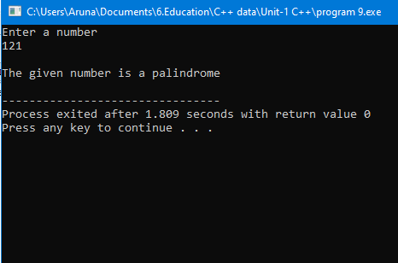

1. Write a program to check whether the number is armstrong or not?

#include<iostream>

#include<conio.h>

using namespace std;

int main()

{

int num,rem,sum,n;

cout <<"Enter a number : \n";

cin >>num;

sum=0;

num=n;

while(n!=0)

{

rem=n%10;

sum=sum+rem*rem*rem;

n=n/10;

}

if(sum==num)

{

cout <<"The given number is an armstrong number \n";

}

else

{

cout<< "The given number is not an armstrong number \n";

}

return 0;

}

Output :-

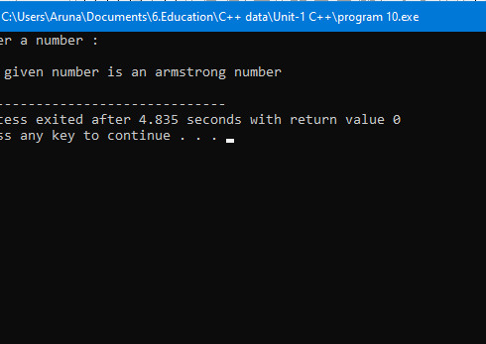

1. Write a c++ program to find the area of triangle,square,circle and rectangle?

#include<iostream>

#include<conio.h>

using namespace std;

int main()

{

int side,base,height,rad,length,breadth;

int square,rectangle;

float triangle,circle;

cout <<"Enter the length of the side a square : \n";

cin >>side;

square=side*side;

cout <<"The area of the given square is : \n"<<square;

cout <<"Enter the base length of a triangle : \n";

cin >>base;

cout <<"Enter the height of a triangle : \n";

cin >>height;

triangle=(0.5)*base*height;

cout <<"The area of the triangle is : \n"<<triangle;

cout <<"Enter the radius of a circle : \n";

cin >>rad;

circle=(2*3.142)*(rad*rad);

cout <<"The area of the given circle is : \n"<<circle;

cout <<"Enter the length of a rectangle : \n";

cin >>length;

cout <<"Enter the breadth of a rectangle : \n";

cin >>breadth;

rectangle=length*breadth;

cout <<"The area of the given rectangle is : \n"<<rectangle;

return 0;

}

OUTPUT :-

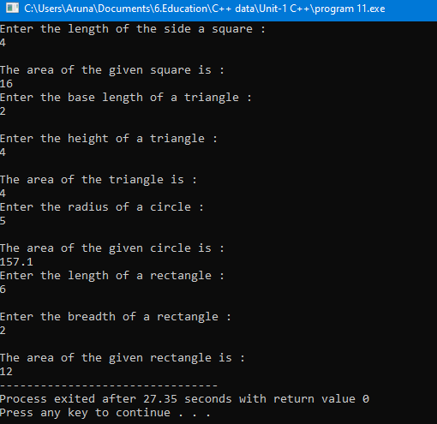

1. Write a c++ program to find the factorial of a number?

#include<iostream>

#include<conio.h>

using namespace std;

int main()

{

int i,num,fact=1;

cout << "Enter a number to find its factorial:\n";

cin >> num;

for(i=1;i<=num;i++)

{

fact = fact *i;

}

cout <<"Factorial of the given number is:\n"<<fact;

return 0;

}

OUTPUT :-

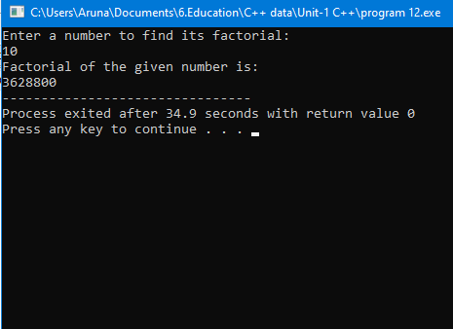

1. Write a program to print the fibonacci series upto given number?

#include<iostream>

#include<conio.h>

using namespace std;

int main()

{

int i,num,next_term,t1=0,t2=1;

cout <<"Enter your number of terms:\n";

cin >>num;

cout <<"Fabinocci series is:\n";

for (i = 1; i <= num; ++i)

{

cout << t1 <<"\t";

next_term = t1 + t2;

t1 = t2;

t2 = next_term;

}

}

OUTPUT:-

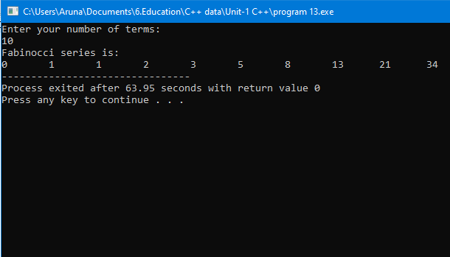

1. Write a program to calculate the simple interest?

#include<iostream>

using namespace std;

int main()

{

int p,r,t,i;

cout<<"Enter Principle : ";

cin>>p;

cout<<"Enter Rate : ";

cin>>r;

cout<<"Enter Time : ";

cin>>t;

i=(p*r*t)/100;

cout<<"Simple interest is : "<<i;

return 0;

}

OUTPUT :-

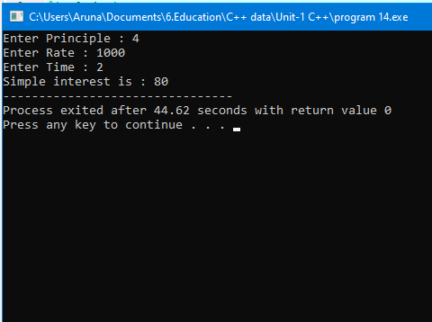

1. Write a program to check whether the given year is leap or not?

#include<iostream>

#include<conio.h>

using namespace std;

int main()

{

int year;

cout <<"Enter a year : \n";

cin >>year;

if(year%4==0)

{

cout <<"The given year is a leap year \n";

}

else

{

cout <<"The given year is not a leap year \n";

}

}

OUTPUT :-

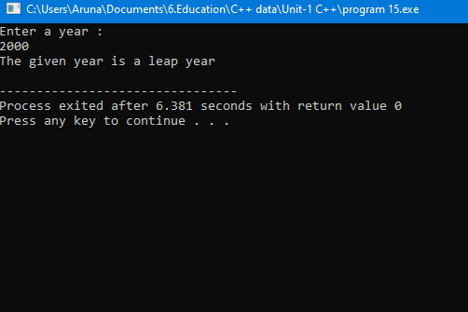

1. Write a program to sum of n natural numbers,sum of squares of n numbers and sum of cubes of n numbers?

#include<iostream>

using namespace std;

int squaresum1(int num)

{

int sum = 0;

for (int i = 1; i <= num; i++)

sum += (i * i);

return sum;

}

int squaresum(int n)

{

int sum2=0;

for(int j=1;j<=n;j++)

sum2+=(j*j*j);

return sum2;

}

int main()

{

int n;

cout<<"Enter a number:\n";

cin>>n;

cout<<"Sum of squares of the numbers upto gven number is :\n";

cout << squaresum1(n) << endl;

cout<<"Sum of cubes of the numbers upto gven number is :\n";

cout << squaresum(n) << endl;

return 0;

}

OUTPUT:-

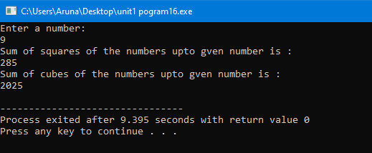

1. Write a program to find largest of two numbers and largest of three numbers?

#include<iostream>

#include<conio.h>

using namespace std;

int main()

{

int num1,num2;

int x,y,z;

cout <<"Enter the values of num1 and num2 :\n";

cin >>num1>>num2;

if(num1>num2)

{

cout <<"\nnum1 is greater than num2 \n";

}

else

{

cout <<"\nNum2 is greater than \n";

}

cout <<"\nEnter the values of x and y and z : \n";

cin >>x>>y>>z;

if(x>y && x>z)

{

cout <<"\nX greater \n";

}

else if(y>x && y>z)

{

cout <<"\nY is greater \n";

}

else

{

cout <<"\nZ is greater \n";

}

return 0;

}

OUTPUT :-

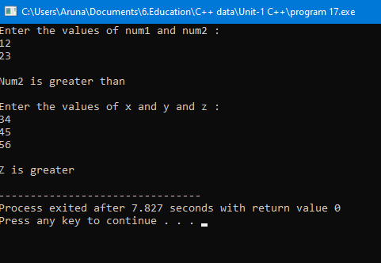

1. Write a program to find the factors of a given number?

#include <iostream>

using namespace std;

int main()

{

int n, i;

cout << "Enter a positive integer: ";

cin >> n;

cout << "Factors of " << n << " are: " << endl;

for(i = 1; i <= n; ++i)

{

if(n % i == 0)

cout << i << endl;

}

return 0;

}

OUTPUT :-

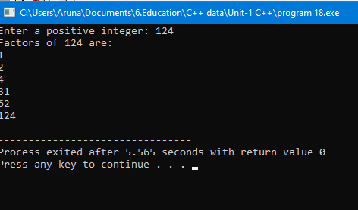

1. Write a program to check whether the given number is perfect or not?

#include<iostream>

using namespace std;

int main ()

{

int i, num, div, sum=0;

cout << "Enter the number to be checked : ";

cin >> num;

for (i=1; i < num; i++)

{

div = num % i;

if (div == 0)

sum = sum + i;

}

if (sum == num)

cout << "\n" << num <<" is a perfect number.";

else

cout << "\n" << num <<" is not a perfect number.";

return 0;

}

OUTPUT :-

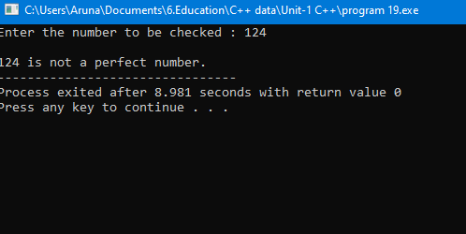

1. Write a program to find LCM of given numbers?

#include <iostream>

using namespace std;

int main()

{

int n1, n2, max;

cout << "Enter two numbers: ";

cin >> n1 >> n2;

max = (n1 > n2) ? n1 : n2;

do

{

if (max % n1 == 0 && max % n2 == 0)

{

cout << "LCM = " << max;

break;

}

else

++max;

} while (true);

return 0;

}

OUTPUT :-

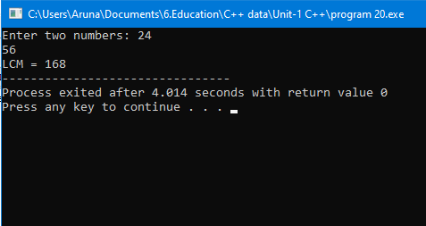

1. Write a program to find the GCD of the given numbers?

#include <iostream>

using namespace std;

int main()

{

int n1, n2;

cout << "Enter two numbers: ";

cin >> n1 >> n2;

while(n1 != n2)

{

if(n1 > n2)

n1 -= n2;

else

n2 -= n1;

}

cout << "HCF = " << n1;

return 0;

}

OUTPUT :-

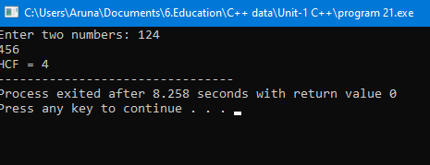

1. Write a program to find the power of a number?

#include <iostream>

using namespace std;

int main()

{

int exponent;

float base, result = 1;

cout << "Enter base and exponent respectively: ";

cin >> base >> exponent;

cout << base << "^" << exponent << " = ";

while (exponent != 0)

{

result *= base;

--exponent;

}

cout << result;

return 0;

}

OUTPUT :-

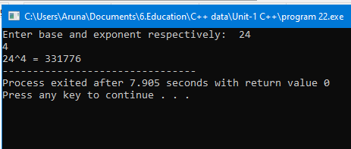

1. Write a program to find the prime numbers within given two intervals?
2. write a program to find the armstrong numbers within given two intervals?
3. write a program to find the Perfect numbers within given two intervals?

#include<iostream>

#include<conio.h>

using namespace std;

int isPerfect(int num);

void printPerfect(int start, int end);

int main()

{

int start, end;

cout<<"Enter lower limit to print perfect numbers: ";

cin>>start;

cout<<"Enter upper limit to print perfect numbers: ";

cin>>end;

cout<<"All perfect numbers between "<<start<< " to "<<end <<" are: "<<endl;

printPerfect(start, end);

return 0;

}

int isPerfect(int num)

{

int i, sum;

sum = 0;

for(i=1; i<num; i++)

{

if(num % i == 0)

{

sum += i;

}

}

if(sum == num)

return 1;

else

return 0;

}

void printPerfect(int start, int end)

{

while(start <= end)

{

if(isPerfect(start))

{

cout<<start<<endl;

}

start++;

}

}

OUTPUT :-

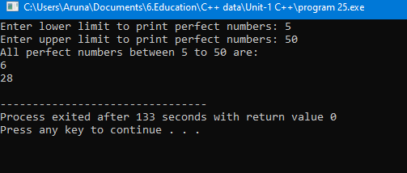

26. Write a c++ program to find the average of given

numbers?

#include<iostream>

using namespace std;

int main()

{

int n, i;

float num[100], sum=0.0, average;

cout << "Enter the numbers of data: ";

cin >> n;

while (n > 100 || n <= 0)

{

cout << "Error! number should in range of (1 to 100)." << endl;

cout << "Enter the number again: ";

cin >> n;

}

for(i = 0; i < n; ++i)

{

cout << i + 1 << ". Enter number: ";

cin >> num[i];

sum += num[i];

}

average = sum / n;

cout << "Average = " << average;

return 0;

}

OUTPUT:-

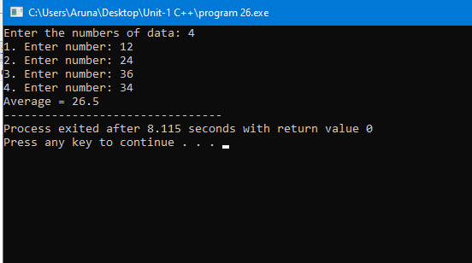

27. Write a c++ program to find the roots of a quadratic

equation?

#include<iostream>

#include<conio.h>

#include<cmath>

using namespace std;

int main()

{

float x1,x2,a,b,c,dis,real,img;

cout<<"Enter co-efficients a,b and c : \n";

cin>>a>>b>>c;

if(dis>0)

{

x1=(-b+sqrt(dis))/(2*a);

x2=(-b-sqrt(dis))/(2*a);

cout<<"Roots are real and different "<<endl;

cout<<"x1= "<<x1<<endl;

cout<<"x2= "<<x2<<endl;

}

else if(dis==0)

{

cout<<"roots are real and same"<<endl;

x1=(-b+sqrt(dis))/(2*a);

cout<<"x1=x2= "<<x1<<endl;

}

else

{

real=-b/(2*a);

img=sqrt(-dis)/2*a;

cout<<"Roots are ccomplex and different \n";

cout<<"x1= "<<real<<"+"<<img<<"i"<<endl;

cout<<"x2= "<<real<<"-"<<img<<"i"<<endl;

}

return 0;

}

OUTPUT:-

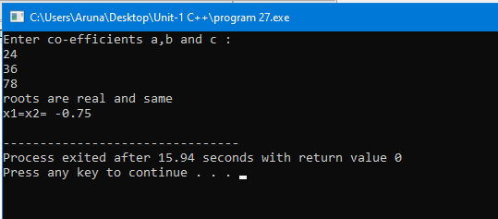

1. write a program to perform arithmetic operations using switch case?

#include<iostream>

using namespace std;

int main()

{

char op;

float num1, num2;

cout << "Enter operator either + or - or * or /: ";

cin >> op;

cout << "Enter two operands: ";

cin >> num1 >> num2;

switch(op)

{

case '+':

cout << num1+num2;

break;

case '-':

cout << num1-num2;

break;

case '*':

cout << num1*num2;

break;

case '/':

cout << num1/num2;

break;

default:

cout << "Error! operator is not correct";

break;

}

return 0;

}

OUTPUT:-

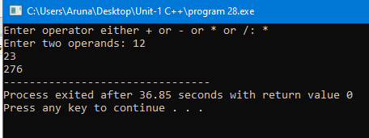

1. write a program to print ASCII value of a character?

#include<iostream>

using namespace std;

int main()

{

char c;

cout << "Enter a character: ";

cin >> c;

cout << "ASCII Value of " << c << " is " << int(c);

return 0;

}

OUTPUT:-

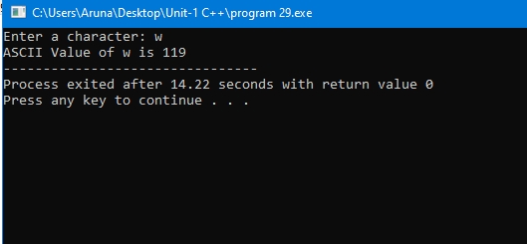

1. write a program to check whether the given number is positive or negative or zero?

#include<iostream>

#include<conio.h>

using namespace std;

int main()

{

int n;

cout<<"Enter the value of number :\n";

cin>>n;

if(n>0)

{

cout<<n<<"\t Is a positive number\n";

}

else if(n==0)

{

cout<<n<<"\t Is equal to zero\n";

}

else

{

cout<<n<<"\t Is a negative number\n";

}

return 0;

}

OUTPUT:-

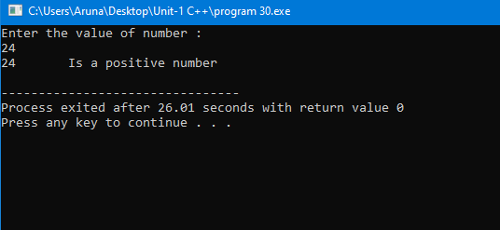

31.Write a c++ program to print the size of various data

types?

#include <iostream>

using namespace std;

int main()

{

int integerType;

char charType;

float floatType;

double doubleType;

cout << "Size of int is: " <<

sizeof(integerType) <<"\n";

cout << "Size of char is: " <<

sizeof(charType) <<"\n";

cout << "Size of float is: " <<

sizeof(floatType) <<"\n";

cout << "Size of double is: " <<

sizeof(doubleType) <<"\n";

return 0;

}

OUTPUT:-

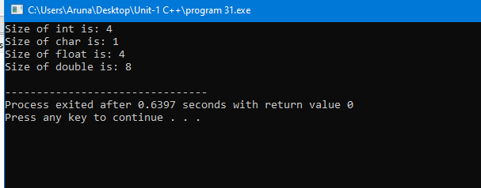

32.Write a c++ program to print half pyramid?

#include <iostream>

using namespace std;

int main()

{

int rows;

cout << "Enter number of rows: ";

cin >> rows;

for(int i = 1; i <= rows; ++i)

{

for(int j = 1; j <= i; ++j)

{

cout << j << " ";

}

cout << "\n";

}

return 0;

}

OUTPUT:-

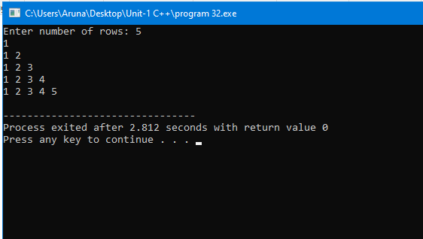

33.Write a c++ program to print pyramid?

#include <iostream>

using namespace std;

int main()

{

int space, rows;

cout <<"Enter number of rows: ";

cin >> rows;

for(int i = 1, k = 0; i <= rows; ++i, k = 0)

{

for(space = 1; space <= rows-i; ++space)

{

cout <<" ";

}

while(k != 2*i-1)

{

cout << "* ";

++k;

}

cout << endl;

}

return 0;

}

OUTPUT:-

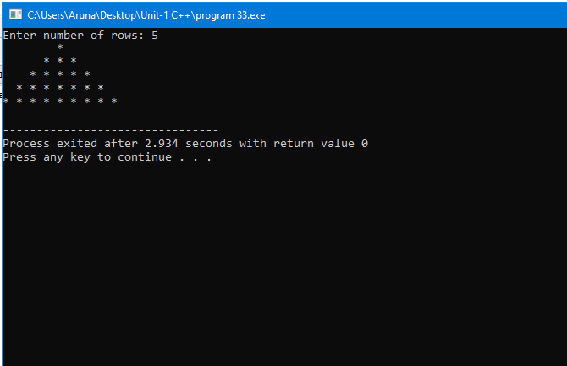

34.Write a c++ program to print diamond?

#include<iostream>

#include<conio.h>

using namespace std;

int main()

{

int n, c, k, space=1;

cout<<"Enter number of rows (for diamond dimension) : ";

cin>>n;

space=n-1;

for (k=1; k<=n; k++)

{

for(c=1; c<=space; c++)

{

cout<<" ";

}

space--;

for(c=1; c<=(2*k-1); c++)

{

cout<<"*";

}

cout<<"\n";

}

space=1;

for(k=1; k<=(n-1); k++)

{

for(c=1; c<=space; c++)

{

cout<<" ";

}

space++;

for(c=1 ; c<=(2*(n-k)-1); c++)

{

cout<<"*";

}

cout<<"\n";

}

getch();

}

OUTPUT:-

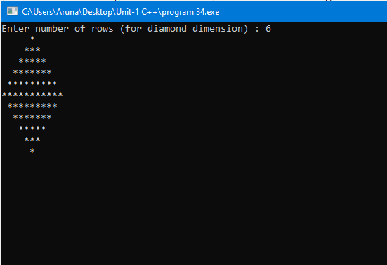

35.Write a c++ program to print reverse half pyramid?

#include <iostream>

using namespace std;

int main()

{

int rows;

cout << "Enter number of rows: ";

cin >> rows;

for(int i = rows; i >= 1; --i)

{

for(int j = 1; j <= i; ++j)

{

cout << "* ";

}

cout << endl;

}

return 0;

}

OUTPUT:-

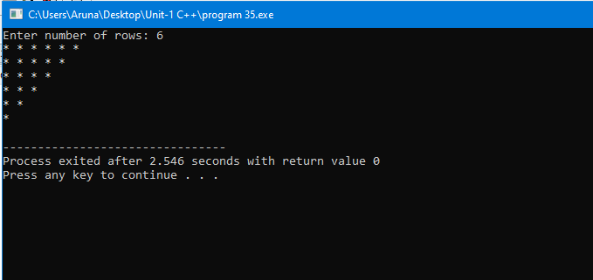

36.Write a c++ program to print reverse pyramid?

#include <iostream>

using namespace std;

int main()

{

int rows;

cout << "Enter number of rows: ";

cin >> rows;

for(int i = rows; i >= 1; --i)

{

for(int space = 0; space < rows-i; ++space)

cout << " ";

for(int j = i; j <= 2*i-1; ++j)

cout << "* ";

for(int j = 0; j < i-1; ++j)

cout << "* ";

cout << endl;

}

return 0;

}

OUTPUT:-

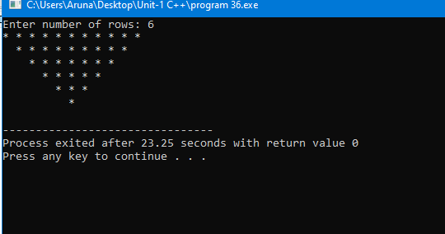

37.Write a c++ program to print Floyd triangle?

#include <iostream>

using namespace std;

int main()

{

int rows, number = 1;

cout << "Enter number of rows: ";

cin >> rows;

for(int i = 1; i <= rows; i++)

{

for(int j = 1; j <= i; ++j)

{

cout << number << " ";

++number;

}

cout << endl;

}

return 0;

}

OUTPUT:-

